Mrs. Rogge’s December Snack Calendar
- Please send pre-portioned snacks for 20 scholars. Thank you! (Don’t forget spoons if necessary!)
- Your child will also be the classroom “Noodle Master” on this day!
Sunday | Monday | Tuesday | Wednesday | Thursday | Friday | Saturday
2 | 3  Gretchen | 4  Hattie | 5  Huck | 6  Davis | 7  Vinny | 8
9 | 10  Ella | 11  Elisa | 12  Amira | 13  Gus  Happy B-day!  Vera | 14  Keagan | 15
16 | 17  Grace | 18  Leo | 19  Book Assembly  Book Week  Ben | 20 | 21  Zana | 22
23 | 24 | 25 | 26  No School  W I N T E R B R E A K  No School | 27 | 28 | 29
30 | 31 | January 1 | 2 | 3 | 4 | 5
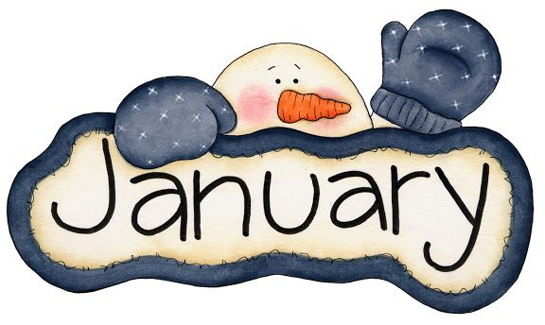

Mrs. Rogge’s January Snack Calendar
- Please send pre-portioned snacks for 20 scholars. Thank you! (Don’t forget spoons if necessary!)
- Your child will also be the classroom “Noodle Master” on this day!
Sunday | Monday | Tuesday | Wednesday | Thursday | Friday | Saturday
30 | 31 | January 1 | 2  W I N T E R B R E A K | 3 | 4 | 5
6 | 7  Gabriel | 8  Happy B-day!  Addy | 9  Louis | 10  William | 11  Calista | 12
13 | 14  Ella | 15  Gretchen | 16  Hattie | 17  Davis | 18  No  School | 19
20 | 21  No  School | 22  Amira | 23  Vinny | 24  Elisa | 25  Virtue Assembly  9:45-10:15  Gabriel | 26  Happy B-day,  Gabriel
27 | 28  Huck | 29  Gus | 30  Keagan | 31  Grace | February 1  Leo | 2
3 | 4  Ben | 5  Vera | 6  Zana | 7  Addy | 8  Louis | 9
February 11th: William February 12th: Calista
No School
No School

